E-commerce Dashboard Project

- Sales and Profit Month wise

The below table shows the sums of sales and profit based on months and product categories. From the table it is evident that the sales and profit is at its maximum value on the month of October and the minimum value of sales in July.
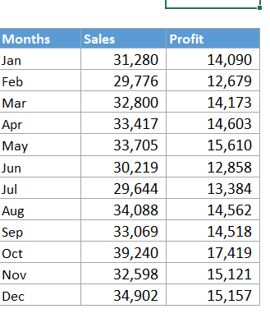

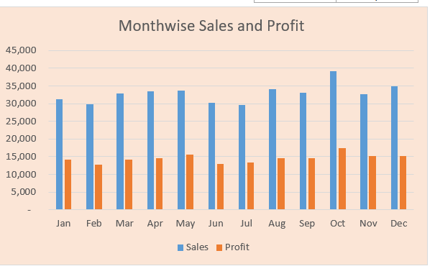
The column chart above shows the representation of the sales and profit for each month which is created based on the above month wise sales and profit table.
- Sales based on Region

The below table and bar chart represent the sum of sales based on different regions and categorised based on the product category.

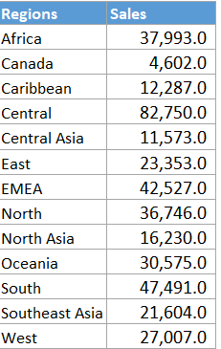

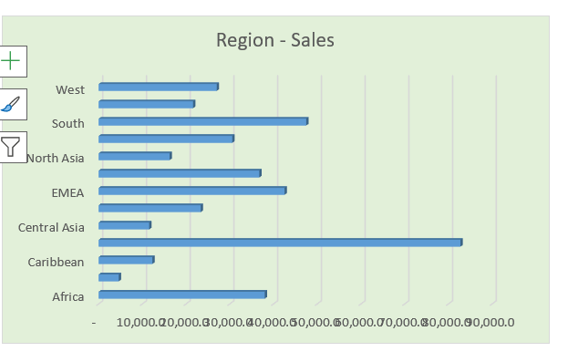
From the graph we can see that the net sales is greater at the Central region and less value is at the Canada region.

- Histogram

The below histogram shows the relation between frequency of sales and cumulative percentage of sales quantity.
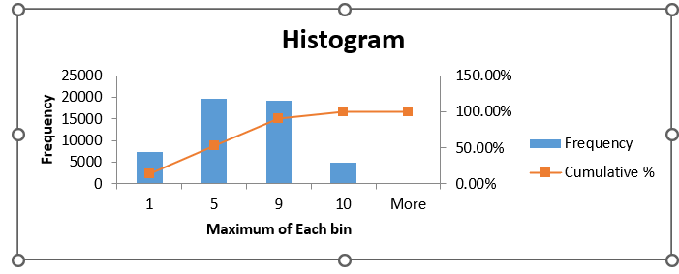

- Combobox for Product Category

The below image shows the list of product categories and combo box for the product category that is linked to the tables of month-wise ad region-wise sales tables.

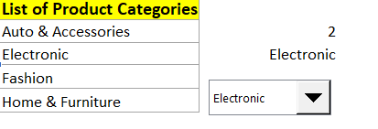

- Dashboard

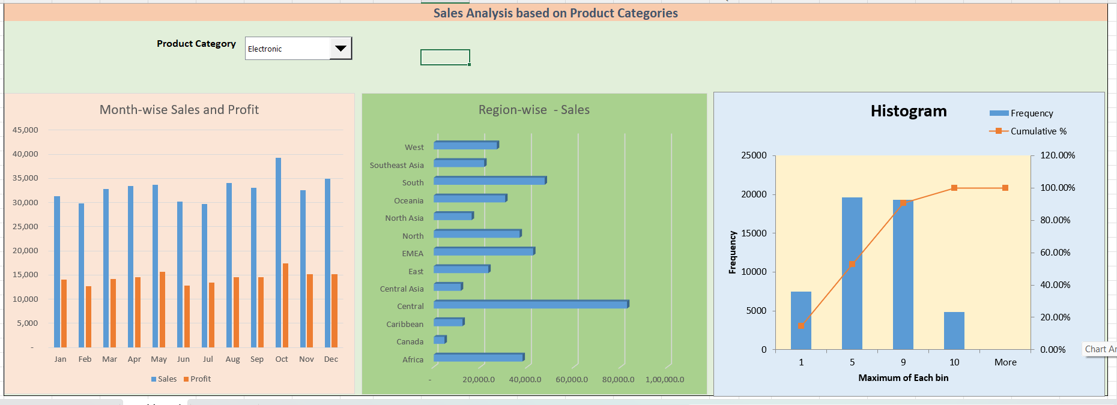

The above image shows the final dashboard that illustrates the sales analysis based on month- wise and region-wise and depends on the of product category – Electronics. The dashboard also contains the histogram we created earlier.
The net sales and profit amount is higher in the month October than other month and net sales is less in the month July and net profit is less in June. Even though the nest sales is less than June, July has the higher profit value than June.
Region wise sales are higher in Central region than other regions and lesser in Canada region.

